**2023 AGFD Awardees**

Award for the Advancement of Application of Agricultural and Food Chemistry

Sponsored by: International Flavors and Fragrances

**Liangli (Lucy) Yu**, Ph.D., Distinguished University Professor

Department of Nutrition and Food Science, 3303 MMH, University of Maryland

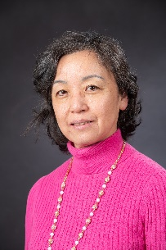Prof. Yu’s research focuses on three main areas: nutraceuticals and functional foods, chemical aspects of food safety, and analytical technologies to ensure food integrity. Dr. Yu’s thought leadership has resulted in her group reporting for the first time: the free radical scavenging components in wheat grain, natural antioxidants and anti-inflammatory components from seed flours – previously a waste stream, free radical properties of conjugated linoleic acids (CLA) - different reactions of CLA isomers with DPPH radicals, prevention of peroxidation of ω-3 fatty acids EPA and DHA during procession and storage by extracts of Chardonnay grape and back raspberry seeds, free radical generation and mediation 3-MCPD diesters from diacylglycerol (DAG) were under high temperature and low moisture conditions, and Fe2+/ Fe3+ can catalyze the 3-MCPD ester formation reactions. Lucy and her team have also devised new methodology for detecting milk adulteration by combining chromatographic fingerprints with statistical analysis, and they devised a novel approach to detect unknown food toxicants by combining cultured kidney cells and hepatocytes with chemometric analyses.

Professor Yu has mentored 17 PhD and 12 MS students, 1 junior faculty, 24 visiting professors/scholars/PhD students and 12 undergraduate students. She has authored 289 peer reviewed journal articles, 18 book chapters, 2 edited 5 books, translated 1 book, holds 3 patents -9 patent applications - 6 Invention disclosures , and delivered over 100 invited or peer reviewed presentations.

Dr. Yu is a Fellow of the American Chemical Society (ACS), the ACS Agricultural and Food Chemistry Division, and the Institute of Food Technologists (IFT). Among her many other awards are the 2008 ACS-AGFD Young Scientist Research Award, and 2020 Stephen S. Chang Award for Lipid or Flavor Science from IFT.

photo by Edwin Remsberg

Young Scientist Award

**Xiaonan Sui**, PhD Professor, Associate Head

Department of Cereals, Oils and Vegetable Protein Engineering, College of Food Science, Northeast Agricultural University, Harbin 150030, China

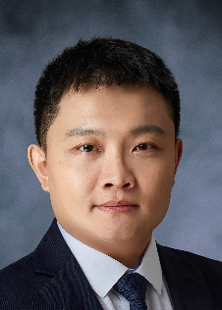Prof. Sui’s research has focused on how soy proteins conformation is impacted by food processing parameters, and how soy proteins aggregate/ self-assemble in multiple dimensions. He has developed a cost-efficient and fiber-rich extrusion method to develop soy-protein based meat alternatives. Engineering soy protein-based connective layers (epimysium and perimysium) enabled him to overcome a key challenge in developing whole cut meat alternatives. He has published 144 peer-reviewed papers, has one patent pending, edited one book and authored two books in English. His research has been cited over 3200 times with an h-index of 33 and an i10 index of 48.

Young Industrial Scientist Award

**Zhuohong (Kenny) Xie**, Ph.D. Principal Scientist

US Pharmacopeia, 12601

Twinbrook Parkway, Rockville, MD 20852

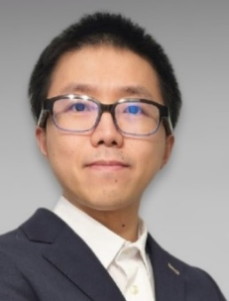 Dr. Xie is the inaugural recipient of the AGFD Young Industrial Scientist Award. This award is to recognize and highlight the important contributions that early career industrial chemists make to our field. Dr. Xie’s work has focused on creating and applying methods and standardized documents that ensure safety, authenticity and efficacy of foods, ingredients and additives. He played a lead role in Expert Panels that developed non-targeted methods and standards for milk ingredients and dietary protein. He has developed more than a dozen standards and three sets of reference materials. Dr. Xie also developed an in vitro model for carbohydrates; optimizing reagents, apparatus, and conditions to simulate digestion. He has developed and validated analytical methods to detect adulterants in food proteins, oils and spices.

Kenny is active in AGFD he is the Vice-Chair of the Functional Foods & Natural Products subdivision; he has co-organized multiple symposia at national meetings; and he led proposal development and coordinates the AGFD led Food Security- Tacking Hunger Convergent Chemistry Community, which includes AGRO, ANYL, and ENVR.

Dr. Xie holds two patents and has 39 peer-reviewed publications.

AGFD Fellows

**Shiming Li**, PhD, Huanggang National University, Hubei Province, P.R.China

**Rickey Y. Yada**, PhD, The University of British Columbia | Vancouver Campus, Traditional Ancestral Unceded xʷməθkʷəy̓əm Musqueam Territory, Vancouver BC Canada Phone

Roy Teranishi Graduate Fellowship in Food Chemistry

**Kaidi Wang**, Department of Food Science and Agricultural Chemistry, Macdonald Campus McGill University: Advisor Xiaonan Lu

Graduate Student Symposium

Cancelled due to lack of submissions

Undergraduate Poster Competition

1st place (tied):

* **Celina Paoletta**, Christopher Newport University, Hop (Humulus lupulus) phytochemical profiles as a function of growth region by HR-LCMS and GCMS analysis
* **Christopher Prajogo**, UC Davis, Effect of trans vaccenic acid on glucose homeostasis in a mouse model of diet-induced obesity and insulin resistance

2nd place:

* **Bret Watson & Jordon Scalia**, Shippensburg Univ. of Pennsylvania, Maintenance of a Kombucha Starter Preparation

3rd place:

* **Kourtney Collier**, Purdue, Plasticizing Capabilities of Glycerol: Acetic Acid and Choline Chloride: Urea in Potato Thermoplastic Starch film

25 Year AGFD Service Awardees

|  |  |  |  |  |  |  |  |  |  |  |  |  |  |  |  |
| --- | --- | --- | --- | --- | --- | --- | --- | --- | --- | --- | --- | --- | --- | --- | --- |
| |  |  |  | | --- | --- | --- | | Douglas Armstrong | Milda Embuscado | Clayton Ericson | | David Gang | Joseph John Karchesy | Veronica M McBurnie | | Jeff D McCord | Susan A S Parker | Ronald B Pegg | | Alexander G Schauss | Kalidas Shetty | Ronald I Thompson | | Deepthi Kumar Weerasinghe | Douglas Williams | Yan Zheng | |

50 Year AGFD Service Awardees

Rajindra Aneja

Denis Emil Hruza

ACS Fellows from AGFD:

**Omowunmi “Wunmi” Sadik**, Distinguished Professor and Chair Chemistry and Environmental Science, New Jersey Institute of Technology

JAFC Research Article of the Year-AGFD:

Sweet Biotechnology: Enzymatic Production and Digestibility Screening of Novel Kojibiose and Nigerose Analogues, Shari Dhaene, Amar Van Laar, Marc De Doncker, Emma De Beul, Koen Beerens, Charlotte Grootaert, Jurgen Caroen, Johan Van der Eycken, John Van Camp*, and Tom Desmet*

https://doi.org/10.1021/acs.jafc.1c07709

JAFC Research Article of the Year-AGRO

Novel Plant Growth Regulator Guvermectin from Plant Growth-Promoting Rhizobacteria Boosts Biomass and Grain Yield in Rice, Chongxi Liu, Lu Bai, Peng Cao, Shanshan Li, Sheng-Xiong Huang

Sheng-Xiong Huang

https://doi.org/10.1021/acs.jafc.2c07072

Sterling B. Hendricks Memorial Lectureship:

https://www.ars.usda.gov/research/lectures/2023/sb-hendricks/

Gary List, D.Sc., University of Illinois, Urbana-Champaign

Kenneth A Spencer Award for Food and Agricultural Chemistry:

Administered by the Kansas City Local Section

Dr. Joel Coats, Iowa State University

Special Notes:

IFT: Lifetime Achievement Award in honor of Nicolas Appert

See Achievement Awards - IFT.org

***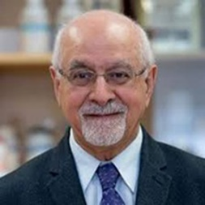*Fereidoon Shahidi**, Ph.D., FACS, FAGFD-ACS, FAOCS, FCIC, FCIFST, FIAFoST, FIFT, FISNFF, FRSC (UK), is a University Research Professor and Distinguished Scholar in the Department of Biochemistry at Memorial University of Newfoundland. He has authored over 1,000 peer-reviewed research papers and book chapters, 78 books, and 10 patents. His research includes nutraceuticals and functional foods with emphasis on lipids, proteins, polyphenols, natural antioxidants and oxidation control in health and disease. He has received numerous awards from the American ACS, AOCS, IFT, and CIFST, among others. He is the past chair of the Scientific Council of IUFoST and the President-elect of the International Academy of Food Science and Technology (IAFoST). He is the editor-in-chief (EiC) of the Journal of Food Bioactives (JFB) and the journal of Food Production, Processing and Nutrition (FPPN). Shahidi is the principal founder of the International Society for Nutraceuticals and Functional Foods (ISNFF) and Founding EiC of the Journal of Functional Foods and serving in that capacity for 10 years. He was the principal founder of the Nutraceutical and Functional Food Division of IFT. He has trained nearly 200 graduate students, highly-qualified personnel, visiting professors, scholars, and PDFs, now his colleagues in over a dozen countries.

IFT Fellow

Xuetong Fan, PhD  
Lead Scientist/Research Food Technologist, U.S. Department of Agriculture

See: www.ift.org/community/awards-and-recognition/ift-fellows

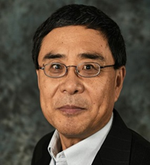Dr. **Xuetong Fan** has worked in the field of postharvest biology and technology, ionizing irradiation and other nonthermal food technologies, food quality, and microbial and chemical safety of foods. His research on the use of 1-methylcyclopropene to extend storage life of fruits and vegetables has led to its commercial application around the world. His studies on food irradiation have helped regulatory agencies make science-based decisions on the approval of irradiation use for lettuce, spinach, and other products. Dr. Xuetong currently leads a group of scientists, technicians, and postdoctoral associates in developing and modifying intervention technologies, as well as combining them with other pathogen-reduction treatments to improve microbial safety of fresh produce, while maintaining sensory and nutritional quality, chemical safety and shelf-life. Over the past 30 years, his work has appeared in more than 450 publications, including 200 peer-reviewed articles. Dr. Xuetong has served as chair of the IFT Fruit and Vegetable Products Division, and several other IFT committees.

202*4* Award Committee

* AAAFC: IFF/AGFD Awards (Michael Morello)
* Young Scientist Awards (Youngmok Kim)
* Young Industrial Scientist Awards (Bhimanagouda (Bhimu) Patel)
* AGFD Fellow Awards (Fereidoon Shahidi)
* AGFD Distinguished Service Award (Michael Tunick)
* Student Awards – Teranishi Fellowship (Liangli (Lucy) Yu)
* Graduate and Undergraduate Student Symposia (Kathryn Deibler)
* Spencer Award (Sarah Leibowitz)
* ACS Fellows Awards (Michael Morello, Michael Appell, Carl Frey)